ATHLETES QUESTIONNAIRE
Cyclo-cross camp 2019
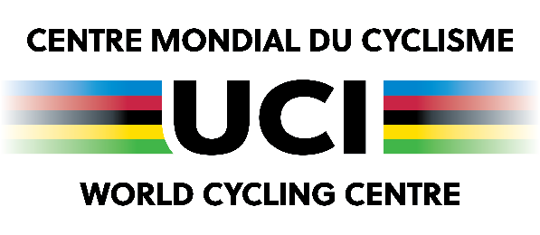
UCI Cyclo-cross Training Camp
Aigle (Switzerland)
1st – 6th October

Personal details

Surname (as mentioned in the passport): First name(s):

Gender: Female Male Nationality:

Date of birth: Place of birth:

Home complete address
Street:

Post code: City: Province:

Country:

Phone numbers
Home: Father or mother’s mobile:

Mobile: Email:

Emergency contact: Relationship and Name: Phone No.:

Passport
Important: please send us a copy of your passport!

Passport nbr:

Date of issue: Valid until:

Dietary / known allergies

Medical information – CONFIDENTIAL

All information will be treated confidentially. This information is necessary to ensure the athletes health.

Surname: Frist name:

Name of your doctor: Email:

Current injures:

Illness:

Current treatment:

What medicine do you take at the moment:

Past injuries/operations/accidents:

Please note all medical information that would be helpful (for example: medicine allergy):

Sporting details

National Federation: Team or club:
Discipline:

Federation’s technical supervisor or National Coach
Please indicate surname, first name, complete address, phone and email:

Results

2018
International event Results Discipline

National event Results Discipline

Objectives

2019

2020

Place and date : Signature :

